
Subject: AI (Lab)
Name: Muhammad Mohsin Nawaz
Roll Number: SU92-BSAIM-F25-102

Instructor: Mr. Rasikh Ali

Task 01:
Trace the supplied tree by hand using Minimax
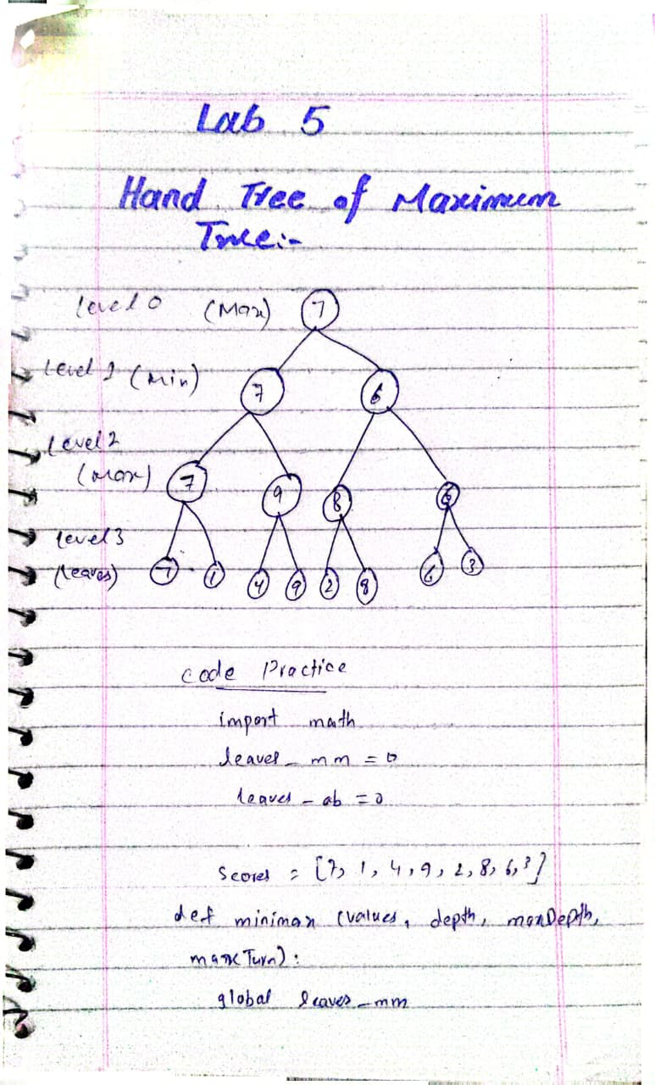

Level 2(Max): I took max of pairs (7,1) gives 7 and (4,9) gives 9
Level 1(Min): I took min of pairs (7,9) which gives 7 and (8,6) gives 6
Level 0 (Max): Root takes max of (7,6) which is 7 my final answer.
Task 2
Output
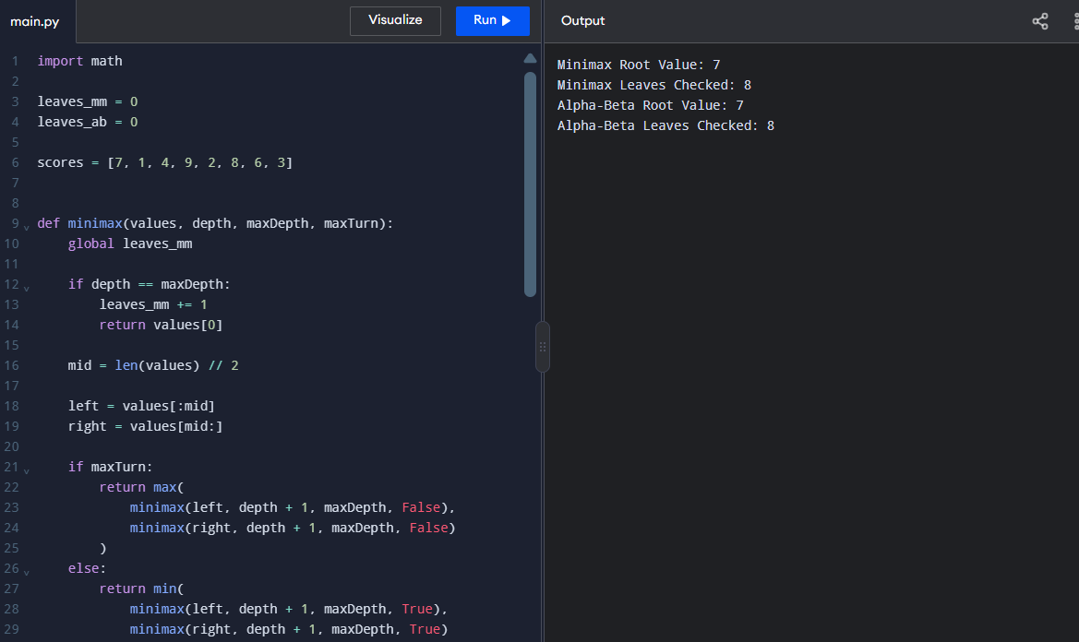
Task 3
Case | Leaf values (Sequence) | Root Value | Minimax leaves | Alpha-Beta leaves
Default tree | [7,1,4,9,2,8,6,3] | 7 | 8 | 8

Result:
Minimax: Evaluates all 8 leaf nodes and returns the root value 7.
Alpha-Beta Pruning: Also evaluates all 8 leaf nodes for this sequence and returns the same root value 7.
Tree Depth: 3

Reflection Questions
Learning: I learned that Minimax finds the best move, while Alpha-Beta pruning saves time by skipping unnecessary branches.
Real World Example: Chess AI uses minimax to choose better moves by predicting the opponent’s possible responses.
Surprise Element: I was surprised that Alpha-beta pruning gives the same result while sometimes checking fewer leaf nodes.
Next time: I will test different move orders to see how they affect the efficiency of Alpha-Beta Pruning.

